# Biographic

DOB: 08/12/1978 (Hornsby)

Age: 40

Address: 10/466 Illawarra rd, Marrickville, NSW, 2204

Phone: +61-478-685-893

eMail: wishcraft@users.sourceforge.net

Website: [https://](http://fonts4web.org.uk/)github.com/Chronolabs-Cooperative

Linked-in: [https://](https://internetfounder.wordpress.com/)linkedin.com/in/founderprinciple

Facebook: [https://facebook.com/SimonSXaies](https://twitter.com/SimonXaies)

Twitter: <https://twitter.com/SimonXaies>

# Education

College: Oakhill College (NSW) (1985 - 1996)  
 School Certificate, College.   
  
 Activities and Societies: Music Studies, Art Studies, Physics, Chemistry, IT Studies, Musicals, Chess club, Computer club, French Studies, Health Studies, Sport

Tertiary: Tafe (NSW) (1992, 2003 - 2005)  
 Computer Programming C (1993)  
 Computer Programming Certificate III (2003-2004)  
 Computer Programming Certificate IV (2004-2005)

RMIT: Masters in Science – IT, Physics & Psychology (2002 - 2008)

Skill Tags: PHP, VBA, VBScript, MySQL, JavaScript, HTML + CSS, XHTML, Apache, CentOS, Ubuntu, Debian, Windows 7, Windows XP, Microsoft Office, Dreamweaver, Open Source Software, Open Source, Operating System, Eclipse, XOOPS, CMS, Backend, Frontend, Adobe Photoshop, Themes, Modules, Application Development, SDLC, SOAP, cURL, XML.

# Work History (From recent)

**Web Technician**[**Communication Research Institute**](http://www.linkedin.com/company/communication-research-institute?trk=ppro_cprof)*Nonprofit; 1-10 employees; Design industry   
September 2008 – Present (3 years 5 months)*

My role is to maintain and upkeep CRI website. This included architectural pressures like web traffic and monitoring of the systems. I have seen Prof. David Sless through several moves of hosting provided up to now where I have moved him to a dedicated service as his domain being 10 years old was beginning to starve resources on shared hosting.  
  
David and the Team at CRI allow for any programming change they need with their site and upkeep of code to demands. I often develop from ground up applications for them including Forums, Content management as well as maintain their existing modular libraries.

Responsibilities: Both the Server Infrastructure and Balancing of the Hosting is my responsibility as well as any new requirements of the business that need to be programmed as well as any smaller PHP changes.

Achievements: Getting a hosting provider David is happy with, learning about business communication from this world leading mind and contributing to his business in a positive and affluent way.

Technologies: MySQL, LAMP, SVN, SMARTY, XOOPS, PHP5, PHP4, CPANEL, APACHE, RED HAT, XML, JSON, JQUERY, ADOBE CS SUITE, ECLIPSE

**XOOPS Developer – PHP Role   
XOOPS Foundation***September 2007 – Present (4 years 5 months)*

As a XOOPS Developer it is predominately my role to maintain the Core of XOOPS which encompasses the key focus of the distribution archive of the XOOPS CMS. XOOPS is a multibillion dollar CMS and remains one of the popular frameworks for the internet still today. It original based in PHPNuke offers an eloquent code base for people to work from with a form and structure that is easy to follow. It has over 600 Million installation world wide and is one of the suites you select from in automated installation with cpanel.  
  
I both maintain an OS Module base which was developed to cover the gaps in the offerings from Xoops as well as being involved and introduction of Licence Keys, Multilingual Support, Multisite, Theme Competitions and being actively involved in this community.

# Work History (From recent)

I also contribute all facites bot module + core of the application. Currently I have been reverse engineering many MVC and planning for XOOPS 3 which will be a ground up developed MVC. XOOPS is regularly project of the month on Sourceforge and I have won several of their awards including Developer of the Year 2011 and several XOOPS Innovation awards for various additions and titles I have added.

Responsibilities: Liaise with the community on module bugs and features, maintain a balance between the needs of the next round of series and the core distribution. Review and report on features and what is on offer with competitor frameworks and present whitepapers on them. Run the module team when the other team lead is away. Design new method of code transactions that make the system confluent with modern pressures as well as fluidity of design. Maintain an SVN.

Achievements: XOOPS Innovator Award x 3, XOOPS Developer of the Year (2011) - Maintain a working balance with the team in a remote environment as well as offering the community a choice of powerful application for the XOOPS Portal.

Technologies: MySQL, LAMP, SVN, SMARTY, XOOPS, PHP5, PHP4, CPANEL, APACHE, DEBIAN, CLASS, MVC, ZEND, CODE IGNITER, CAKEPHP, SYMPHONY, DRUPAL, JOOMLA, WORDPRESS, ORM, ADODB, XML, JSON, JQUERY, ADOBE CS SUITE, ECLIPSE

**Business Owner**   
**Chronolabs **Cooperative (labs.coop)*****June 2006 – Present (5 years 8 months)*

I am the business owner of Chronolabs which is a computing based co-op in Sydney Australia. Chronolabs hold a few marketable trading names and several business opportunities for people parked.

Essentially Chronolabs exists as a foundation for GPL and Open Source licensing in NSW but also operates as a boutique agency for the developers of XOOPS and people wanting websites such as IPTV Stations as well as complex systems of business for ground up development.

We have current reached the end of the SDLC of our product range where I have the option to either seek employment in your business or continue with another 12 months of new series of OS Titles as seen on my Google Code section. Some of the business is consultancy and most of it has been work from home, which means I have a proven track record with self maintaining development of software titles.

# Work History (From recent)

Responsibilities: Maintain a series of libraries and tools which have been released to the ImpressCMS, XOOPSCube and XOOPS Community. Conduct quarterly board meetings with the other directors. Maintain an SVN both on Sourceforge and Google Code. Maintain correspondence with graphic designers and subcontractors. Maintain a bug tracker and fix issues.

Achievements: Understanding a core principle of an open source business. Driving profit margins up as well as delivering results in customer management and end user management.

Technologies: MySQL, LAMP, SVN, SMARTY, XOOPS, PHP5, PHP4, CPANEL, APACHE, RED HAT, DEBIAN, CLASS, MVC, ZEND, CODE IGNITER, CAKEPHP, SYMPHONY, DRUPAL, JOOMLA, WORDPRESS, ORM, ADODB, XML, JSON, JQUERY, ADOBE CS SUITE, ECLIPSE, WOWZA MEDIA SERVER, WURFL

**Software Developer  
Web Programmer Pty Ltd***July 2011 – November 2011 (5 months) Sydney Area, Australia*

I work part time at Web Programmer as a PHP and other languages developer. My responsibility it to manage my tasks from the project management software and utilise SVN to maintain software repositories for WP Clients.

Responsibilities: Maintain a series of libraries and tools which have been released to the by the business to clients for their websites. Correspond with the business owner about functional changes needed to their code base. Maintain an SVN on each server via putty. To work remotely and conversely to provide solutions and results in minimal time.

Achievements: Introducing newer libraries to the business. Achieving a positive report from the business. Provide solutions in timely manner and within the businesses costs.

Technologies: MySQL, LAMP, SVN, SMARTY, XOOPS, PHP5, PHP4, CPANEL, PUTTY, XML, JSON, JQUERY, ADOBE CS SUITE, ECLIPSE

**Infrastructure Director   
Open Source Industry Australia***Nonprofit; Nonprofit Organization Management industry   
November 2010 – November 2011 (1 year 1 month) Sydney Area, Australia*

My role was to attend board meetings and make decissions on infrastructure changes and migration plans, there isn't a huge infrastructure in the OSIA but this covers, phones, website, all hardware and software as well as other physical devices.

# **Work History (Continued)**

**Contract VB6 Developer   
TAG Services.***November 2006 – June 2008 (1 year 8 months)*

My roles in both instances of the contract were to provide ternary changes to existing code bases for BASWare Procurement systems. This was altering Workflow DLLs, IP Transfer Protocols and several of other business logic changes.  
  
I was also in charge of making changes to existing system for exporting XML Feeds to customers and scheduling system for fax pooling.

Responsibilities: Develop business rules into Dynamic Link Libraries that are compatible with Basware Series.

Achievements: Work remotely on the clients system with visual basic 6.0 using meet me now to develop DLL in timely manner.

Technologies: MySQL, MSSQL, VB6, BASWARE

**Contract Project Developer – PHP Role**[**SBS Corporation**](http://www.linkedin.com/company/special-broadcasting-service-sbs-australia?trk=ppro_cprof)*Government Agency; 501-1000 employees; Broadcast Media industry   
September 2007 – November 2007 (3 months)*

At SBS as a contract programmer, I developed multi-lingual systems of dynamic content for shows like Parent Rescue. I was also working on migration and changes to the servers between an older legacy system of servers to a new dynamically hosted system at Hostworks. This migration included the testing and changes to database systems as well as ensuring authentication systems and tunnelling was working.  
  
As well as working on these fundamental functions of the system, I had to make changes to a new CMS system written by another programmer which included structural changes and new functions; this was for sites like Change the World. I also wrote some cron job systems for importing XML into the platform database array.

Responsibilities: Develop website's for TV series with in-house CMS. Report to the management on progress. Cut sites to adobe design.

Achievements: Learning new libraries and CMS. Achieving a positive report from the business. Provide solutions in timely manner and within the businesses costs.

Technologies: MySQL, LAMP, SVN, SMARTY, XML, JSON, JQUERY, ADOBE CS SUITE, ECLIPSE

# **Work History (Continued)**

**Contract Project Developer – BA Role   
Tyco Fire & Security.***April 2007 – May 2007 (2 months)*

My roles at Tyco, was within 3-4 weeks write a report surrounding duplicate customer entries in there different system of customer recording in Tyco, this was around Mastermind & Pronto Databases, I was to draft a report and presentation to the senior management about the best approach to collating and recording the customer in hierarchy as well as unduplicated utilising QAS QuickAddress and other tools to provide their new CRM Application with a valid source of customers.

Responsibilities: Develop report and solution for the director in multiple customer entries for a single base of customer through multiple database. Report to the management on progress. Present meeting and conclusion to senior management.

Achievements: Learn about Tyco Need and requirement. Developing BA Reports and responsibility for new staff. Reporting effectively to the business.

Technologies: MySQL, LAMP, SVN, SMARTY, XML, JSON, JQUERY, ADOBE CS SUITE, ECLIPSE

**Contract PHP Developer**   
**MyHome - PBL.***November 2006 – February 2007 (4 months)*

This job entailed cutting of code and development of new routines. My job was to handle data feeds that would stream information from outsourced websites that would upload information into the www.myhome.com.au website and provide with property listings.  
  
I was also to provide consolidated data on the data feeds and write reports such as the guidelines for future development of the website application for PHP, SQL & Other business tools. I also made additions to the code base, such as reports that would provide a dynamic reporting basis that would be a consistent feed of reporting tools like the percentages of times in averages that images would take to process or the basis of suburbs that have been required to be included in the requestion of property advertisements.

Responsibilities: Develop website's for TV series with in-house CMS. Report to the management on progress. Cut sites to adobe design. Help with bug testing. Provide spam solutions.

Achievements: Learning new libraries and CMS. Achieving a positive report from the business. Provide solutions in timely manner and within the businesses costs.

Technologies: MySQL, LAMP, SVN, SMARTY, XML, JSON, ADOBE CS SUITE, ECLIPSE

# Work History (Continued)

**Contract Web Architect   
TNA Australia Ltd.***July 2006 – August 2006 (2 months)*

My role at TNA, was a very exciting employment opportunity for me as it allow me more exposure to PHP which is a web language I enjoy working in. TNA are in the process of rearing a new look for their company, including new logos, letterheads, website. They have spent a huge amount of cash on getting a new image, which is part of the function of my job.

Responsibilities: Develop website's for business. Report to the management on progress. Cut sites to adobe design and cue cards.

Achievements: Learning new libraries and CMS. Achieving a positive report from the business. Provide solutions in timely manner and within the businesses costs.

Technologies: MySQL, LAMP, SVN, SMARTY, XML, JSON, JQUERY, ADOBE CS SUITE, ECLIPSE

**Solutions Director**   
**Exitstencil Press Pty. Ltd.***May 2001 – June 2006 (5 years 2 months)*

As a director of an organisation that is primary a scientific company, it is my job to provide the other director and his staff with solutions to their business requirements – mainly software architecture. We now have coverage of broadband solutions to 100% of Australia this includes turn-key satellite broadband from a company in upper Asia to cover the remote areas of Australia Since 2002 we have been developing slowly (only being one programmer, myself) a billing solution for this ISP and any resellers that we may have. This has been dubbed – ‘The Nexus’.   
  
This is currently profiled on one of our websites as source code which is an entire business community on the web. The Nexus consist of a relation database with over 100 tables and more than 2500 fields. This is using MySQL the world leading edge in open source database servers. The website was also developed by me, which consist of primary PHP pages which are much like ASP in it operations and most believe more powerful than ASP.

Responsibilities: Develop solutions and billing system for business. Report to the management on progress.

Achievements: Learning new libraries and techniques. Achieving a positive report from the business. Provide solutions in timely manner and within the businesses costs.

Technologies: VB6, XOOPS, MySQL, MSSQL, LAMP, SVN, SMARTY, XML, JSON, JQUERY, ADOBE CS SUITE, ECLIPSE

# Work History (Continued)

**Contract Systems Architect**   
**Sydney Ferries Corporation***February 2005 – March 2005 (2 months)*

My role in this position is to design a maintainable environment that support mapping of timetables and service, Staff, Vessel and other such information for the purpose of data entry on service statistics. This system was commissioned to collect and store information in the Ferries Group that allow for future expansion and simulation of proposed services as well as pre-existing ones.  
  
Responsibilities: Develop solutions for the business in visual basic. Report to the management on progress.

Achievements: Learning new libraries and techniques. Achieving a positive report from the business. Provide solutions in timely manner and within the businesses costs. Provide odd and statistic reports on the software written.

Technologies: MySQL, MSSQL, VB6, BASWARE

**Analysis Programmer – IIS Division (Fraud Investigation)**[**Commonwealth Bank of Australia**](http://www.linkedin.com/company/cba?trk=ppro_cprof)*Public Company; 10,001+ employees; CBA; Financial Services industry   
July 2004 – October 2004 (4 months)*

My role in this short contract was to develop work flow management tools as well as write a complete reporting system for this tool. This project was developed using MS SQL, ASP, VB 6.0 as well a range of other tools. While in this position i was also in charge of implementing a Microsoft NT Server (NT 4.0) and securing this server. I also developed a range of dynamic tools for maintenance and support of this title: Business Systems Request.

Achievements: Learning new libraries and techniques. Achieving a positive report from the business. Provide solutions in timely manner and within the businesses costs. Provide odd and statistic reports on the software written.

Technologies: MySQL, MSSQL, VB6, BASWARE

# **Work History (Continued)**

**Contract Applications Programmer and Support**   
[**Cardlink Services Ltd.**](http://www.linkedin.com/company/cardlink?trk=ppro_cprof)*Privately Held; 201-500 employees; Financial Services industry   
January 2001 – April 2001 (4 months)*

This role included many different fascists of object development as well as solution to the needs of this fraud investigation company. It included development of the   
B-Pay system as well as software for internal use within the company.   
  
Some of the business objects developed here included Information tracking and auto analysing of fiscal systems to search for patterns of fraud within their MS SQL and mainframe databases. One Business system object also included third party OCX called the Janus Grid Control, this was to provide a solution that had the MS Outlook look and feel.

Responsibilities: Develop solutions for the business in visual basic. Report to the management on progress.

Achievements: Learning new libraries and techniques. Achieving a positive report from the business. Provide solutions in timely manner and within the businesses costs. Provide odd and statistic reports on the software written.

Technologies: MSSQL, ORACLE, VB6

# Projects of Interest

### Xortify.com - Honeypot

Xortify.com is entirely my own work. During the development phases of XOOPS we noticed a lot of inactive signups, that is a signup that doesn't seem to do anything after it has registered with a site. It turns out in our research these where a form of human rights abuse for human assisted bots, where essentially in places like India, brazil and china they have a group of people who are essential slaves that are directed to sign up on sites with a username and password to get past the captchas and then record it in a database that a bot uses to Spam attack on the site. This honeypot uses two other honeypot's as well that include Stop forum spam as well as project honeypot to achieve it objectives. This is entirely my research and work, and in finding over 5 of every 6 signups on a site is a captchas sweat shop.

### Open Source Titles - Sourceforge

<http://sourceforge.net/projects/chronolabs>  
<http://sourceforge.net/projects/chronolabsapis>

We recently went from hosting our own titles to hosting them on Google Code, all these titles of software and documents are my own work on this site, they are the result of 6 years of development life-cycles on each title. Somewhere developer for Chronolabs Clients at a reduce rate for open source others have been developed to fill in the gaps.

Some of the more interesting titles include X-Payment, Xortify, X-Forum, Myalbum-p as well as a range of other titles. There is also a fractal based checksum which is based in complexity which is my number for everything this is called XCP or eXtensiable Checksum Process, it has 3 variants which are published QCP64, QCP71, QCP135, you can have a look at this for example at this url: http://xcp.labs.coop

### Prochatrooms - Closed Development

[http://www.prochatrooms.com](http://www.prochatrooms.com/)

All though you will not be able to download this from our open source titles, this is some of the commercial development I have done for the XOOPS community. Prochatrooms.com approached me to make a commercial title of their software for XOOPS, this took around 1 month and through the development life-cycle we have reproduced their software for commercial purchase for the XOOPS Community. I Can provide you this over email if you need to see it.

### Pageflip - Closed Development

[http://www.pageflip.com](http://www.pageflip.com/)

There is a demo copy of this available on our open source section of Google Code, however it will only work on localhost. This is a commercial title I developed in response to the community needing a book displaying method for XOOPS, it is modelled on their commercial publishing software and allows users of XOOPS by replace the flash files from pageflip.com with the commercially bought ones to upload pages and maintain books for display on their XOOPS portal.

# Security Clearance Documentation

Latest crime report – National for Australia from NSW Police:

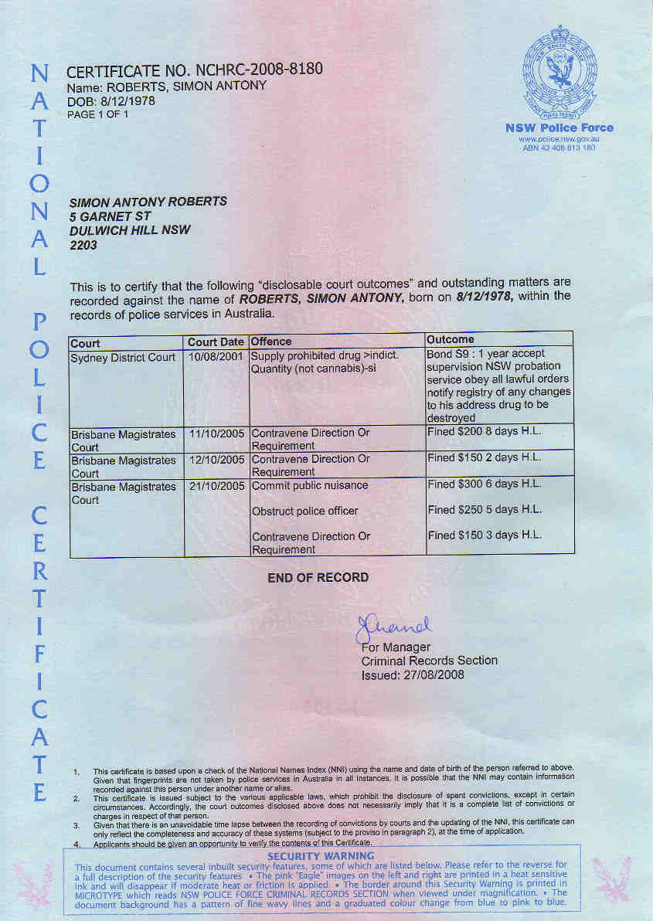

High Security Area Military Passport – Australian – M8747409

